Instructions for oraarch and oradmin, qtree new and growth NAS requests

Capex:
Basically for new loon, the customer must buy a TSM license if they want host os back-ups and/or archive log backups: (Either 7, 14 or 45 day retention)

Plus, they must buy “Back-up NAS Tier1 – 14 Day Retention”, or (“Back-up NAS Tier2 – 14 Day Retention”), for all transaction and archive log back-ups even though they are in a nosnap volume.

In the event the snap volume is only backed up 7 days, “Back-up NAS Tier1 (or Tier2) – 7 Day Retention” should be used.

Capex screen shot:
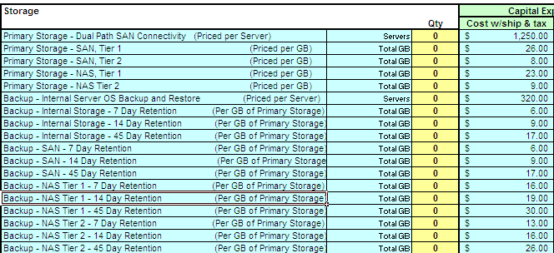

Build Sheet:
For oraarch and oradmin new and growth NAS, “Y-TSM” should be entered in the “SNAP Volume /TSM Backup(Y/N)?” column. (In yellow below)

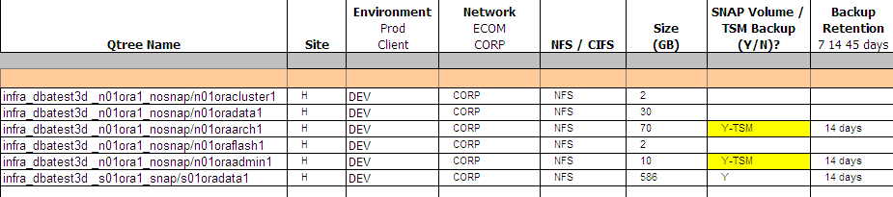

TSM:
In TSM, the “loon” domain is used for oraarch and oradmin back-ups.

